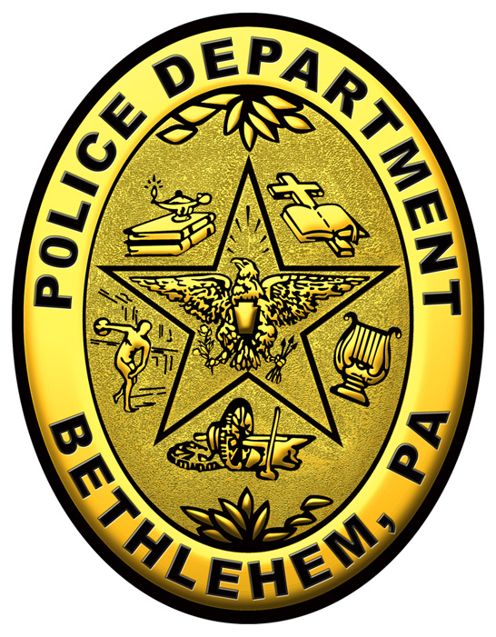 | INTER-DEPARTMENTAL MEMORANDUM
 | TO: | J. William Reynolds, President of Council
 | FROM: | Mark DiLuzio, Chief of Police
 | DATE: | June 6, 2016
 | RE: | Request for Resolution

President Reynolds,

I am requesting that a resolution be passed covering Special Event Parking during Musikfest 2016. The time covered will be from 12:00 p.m. on Friday, August 5, 2016 and last through 11:59 p.m. on Sunday, August 14, 2016.

The Special Events Parking Districts will need to remain the same as last year, including the extension into the South Side.

The North Side Special Events Parking Area is proposed to include the same area as previous years. This area extends from: Lehigh River to the north along 8th Ave. to Eaton Ave., east on Eaton Ave. to Elizabeth Ave., east on Elizabeth to Linden St., south on Linden to the Lehigh River.

The South Side Special Events Parking Area is proposed to extend from the Lehigh River south along Wyandotte St. to 3rd St., east on 3rd St. to Brodhead Ave., south on Brodhead Ave. to W. Packer Ave., east along Packer Ave. to Hillside Ave., south on Hillside Ave. to north along Thomas St., east from Thomas along 6th St. through St. Michael’s Cemetery and continuing along 6th St. to Lynn Ave., north along Lynn Ave. to 4th St., east on 4th St. to Emery St., and north along Emery St. to the Lehigh River.

A map of the proposed boundaries is included with this memorandum for reference.

Thank you for your consideration.

Sincerely;

Mark A. DiLuzio
Chief of Police

